**PROJECT REPORT**

**On**

**Android Location Based Service**

**(CSE IV Semester Mini project PCS-404)**

**2020-2021**



**Submitted to: Submitted by:**

Mr. Dilip Kumar Gangwar Mr. Chiranjib Ghosh

(CC-IV sem-H) Roll. No.: 1918308

**Guided by:** CSE-H-IV-Sem

Mr. Avnish Panwar Session:2020-2021

(Resource Person)

**DEPARTMENT OF COMPUTER SCIENCE AND INFORMATION TECHNOLOGY**

**GRAPHIC ERA HILL UNVERSITY, DEHRADUN**

**CERTIFICATE**

### Certified that Mr. Chiranjib Ghosh (Roll No.- 1918308) has developed mini project on “Android Based Location Service” for the CS IV Semester Mini Project Lab (PCS-504) in Graphic Era Hill University, Dehradun. The project carried out by Students is their own work as best of my knowledge.

Date:

(Mr. Dilip Kumar Gangwar) (Mr. Avnish Panwar)

**Project Co-ordinator Project Guide**

**CC-CSE-H-IV-Sem** Resource Person

(CSE Department) (CSE Department)

GEHU Dehradun GEHU Dehradun

**ACKNOWLEDGMENT**

We would like to express our gratitude to The Almighty Shiva Baba, the most Beneficent and the most Merciful, for completion of project.

We wish to thank our parents for their continuing support and encouragement. We also wish to thank them for providing us with the opportunity to reach this far in our studies.

We would like to thank particularly our project Co-ordinator Mr. Dilip Kumar Gangwar and our Project Guide Mr. Avnish Panwar for his patience, support and encouragement throughout the completion of this project and having faith in us.

At last but not the least We greatly indebted to all other persons who directly or indirectly helped us during this work.

**Mr. Chiranjib Ghosh**

**Roll No.- 1918308**

**CSE-H-IV-Sem**

**Session: 2020-2021**

**GEHU, Dehradun**

**Table of Contents**

**1. Introduction**

* Discussion
* Which code is used

**2. About Project(Snapshot and Code)**

* Requirements
* Implementing

**3. Conclusion**

* Summary

**Introduction**

* This project based on In Android Service. Android always has it’s own Framework for location updates. Android location APIs make it easy for you to build location-aware applications, without needing to focus on the details of the underlying location technology. In this project it’s very easy to get latest location updates through framework.
* For this we need to java code for implementation. Because all kind of location framework is available on java location framework. This language is very high level language and we used various inbuild method as well as interface for implementing this project. All method and class or interface already in android studio. So that it is easy to use the framework and implement the project carefully.
* In this project main file we use the LocationListener interface.
* We used LocationManager.

**Location Quality Service**

The **LocationRequest** object is used to request a quality of service (QoS) for location updates from the **LocationClient**. There are following useful setter methods which you can use to handle QoS. There are equivalent getter methods available which you can check in Android official documentation.

**Requirements:-**

* Windows or Mac
* Android Studio any version
* Knowledge about java programming language

Here we need many method, Interface and Class which are already in Location Framework.

Some methods and Description:

* **double getLatitude()**

Get the latitude, in degrees.

* **double getLongitude()**

Get the longitude, in degrees.

## **Get the Current Location**

To get the current location, create a location client which is **LocationClient** object, connect it to Location Services using **connect()** method, and then call its **getLastLocation()** method. This method returns the most recent location in the form of **Location** object that contains latitude and longitude coordinates and other information as explained above. To have location based functionality in your activity, you will have to implement two interfaces −

* GooglePlayServicesClient.ConnectionCallbacks
* GooglePlayServicesClient.OnConnectionFailedListener

**IMPLEMENTING:-**

1. You will use Android studio IDE to create an Android application and name it as *Location* under a package *com.example.Location.myapplication*.
2. Add *src/GPSTracker.java* file and add required code. GPSTracker is a class which implemented through main fIle.
3. Modify *src/MainActivity.java* file and add required code as shown below to take care of getting current location and its equivalent address.
4. Modify layout XML file *res/layout/activity_main.xml* to add all GUI components which include three buttons and two text views to show location/address.
5. Modify *res/values/strings.xml* to define required constant values
6. Modify *AndroidManifest.xml* as shown below
7. Run the application to launch Android emulator and verify the result of the changes done in the application.

**Android Studio**

**Android Manifest:-**The manifest file describes essential information about your app to the Android build tools, the Android operating system, and Google Play.

This manifest.xml is read by the android system during installation of the application.

**What is AVD or EMULATOR:-**The android tooling contains an android device emulator. This emulator can be used run an Android virtual device. These AVD allows you to test your application on selected android version.

**What is UI:-**User Interface(UI) Design focus on anticipating what user might need to do and ensuring that the interface has elements that are easy to access. Understand and use to facilitate these actions.

**SNAPSHOT:-**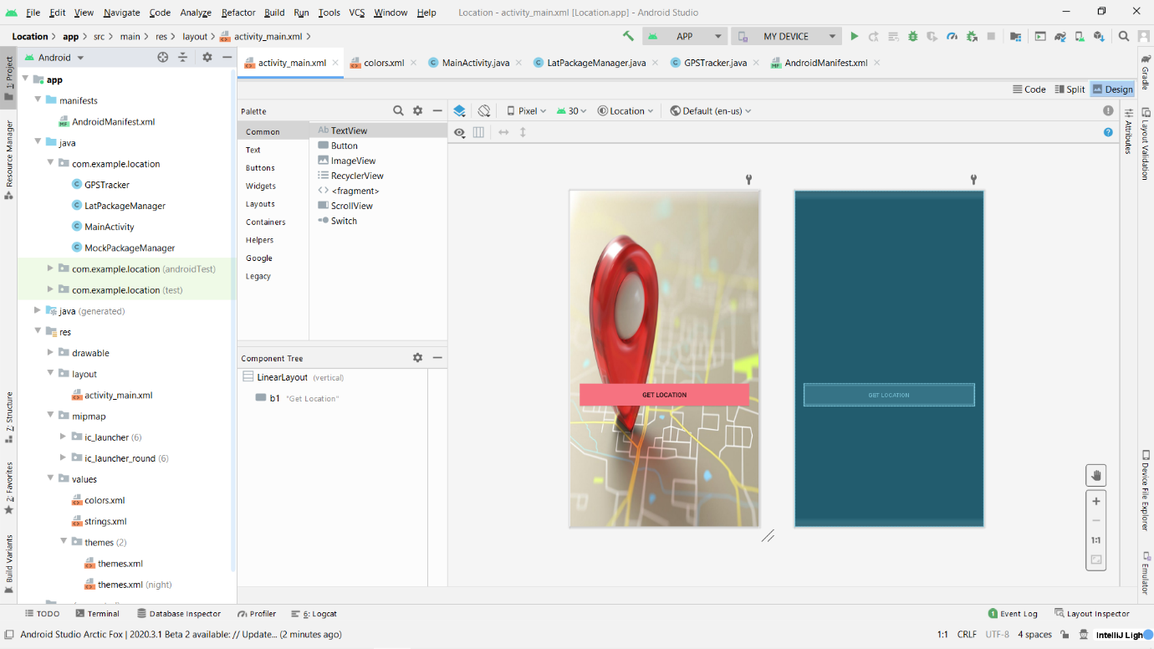

1.Here it is only the design and I used Single LinearLayout for Implementation.

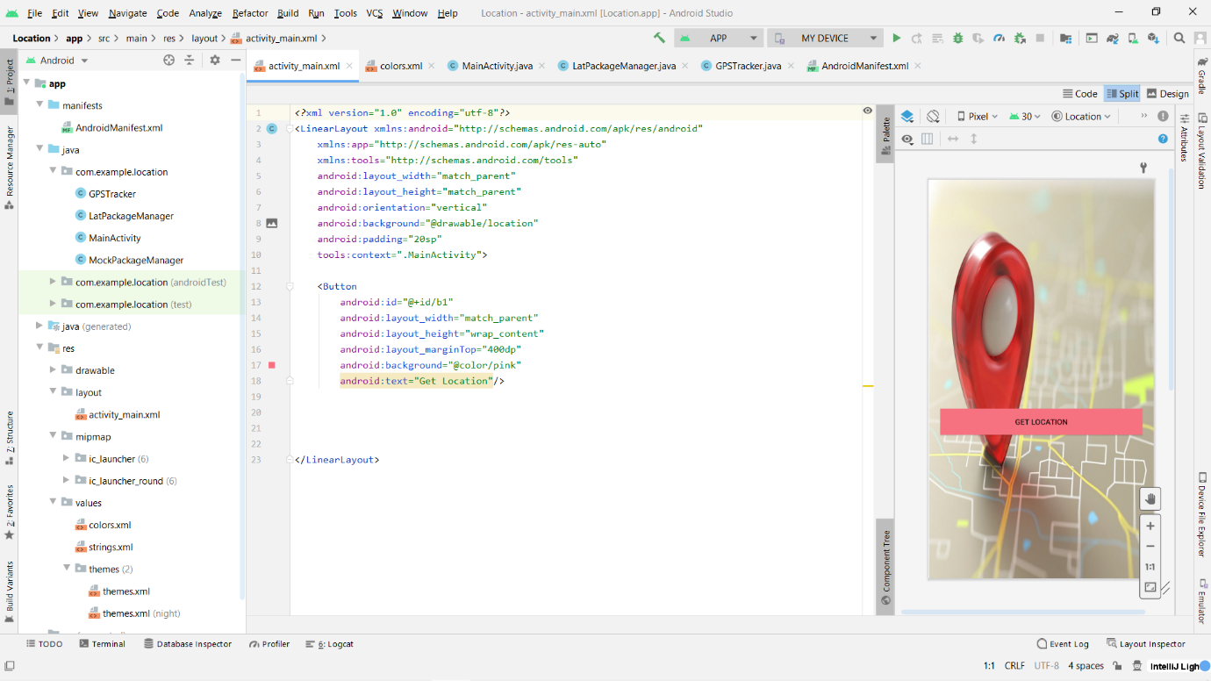

2.We able to see the *xml* part.

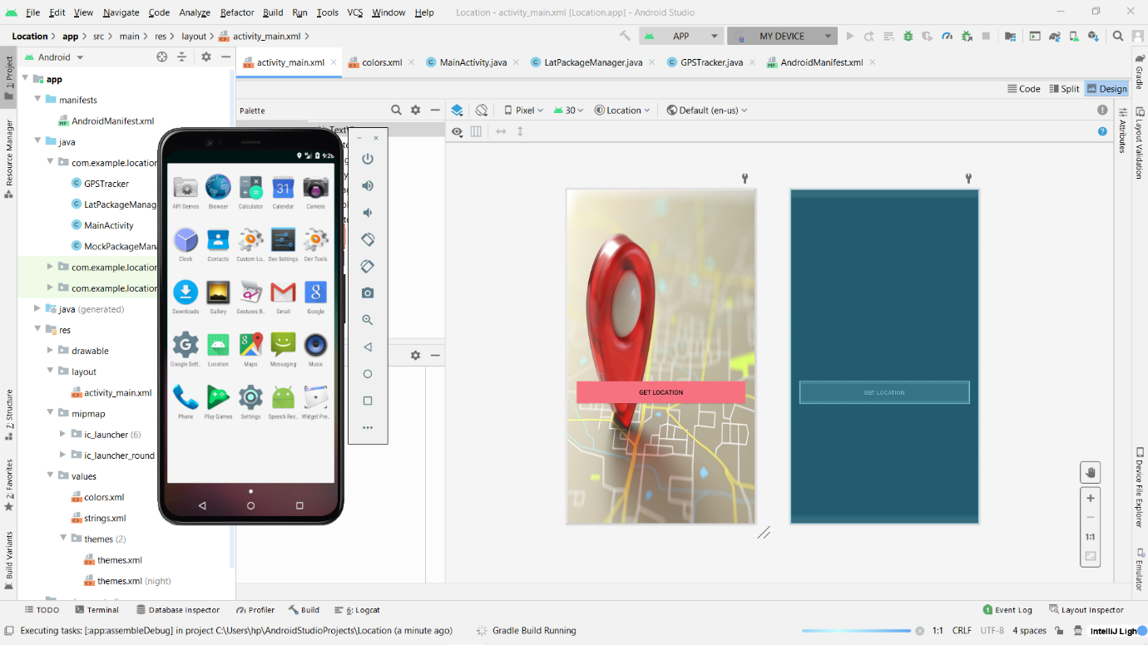

3.Creating Android Virtual Device for running the app.

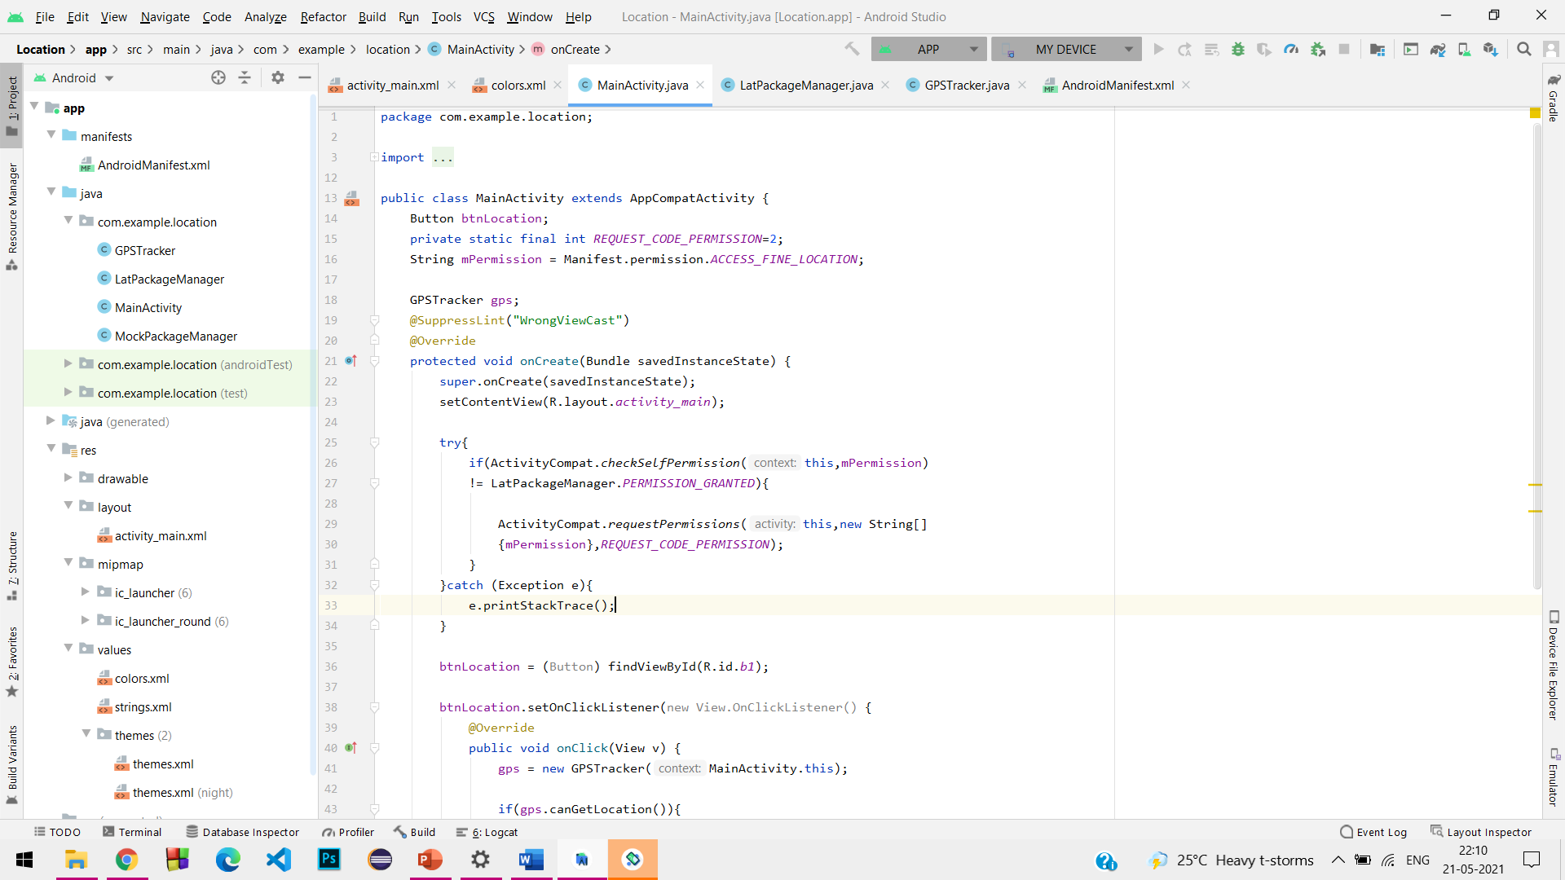

4.*MainActivity.java file* here I implement the GPSTracker class.

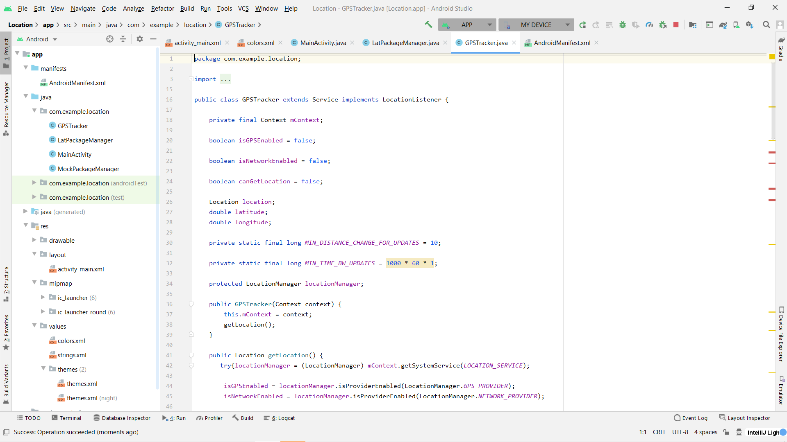

5.*GPSTracker.java* here I used the various method as well as LocationManager.

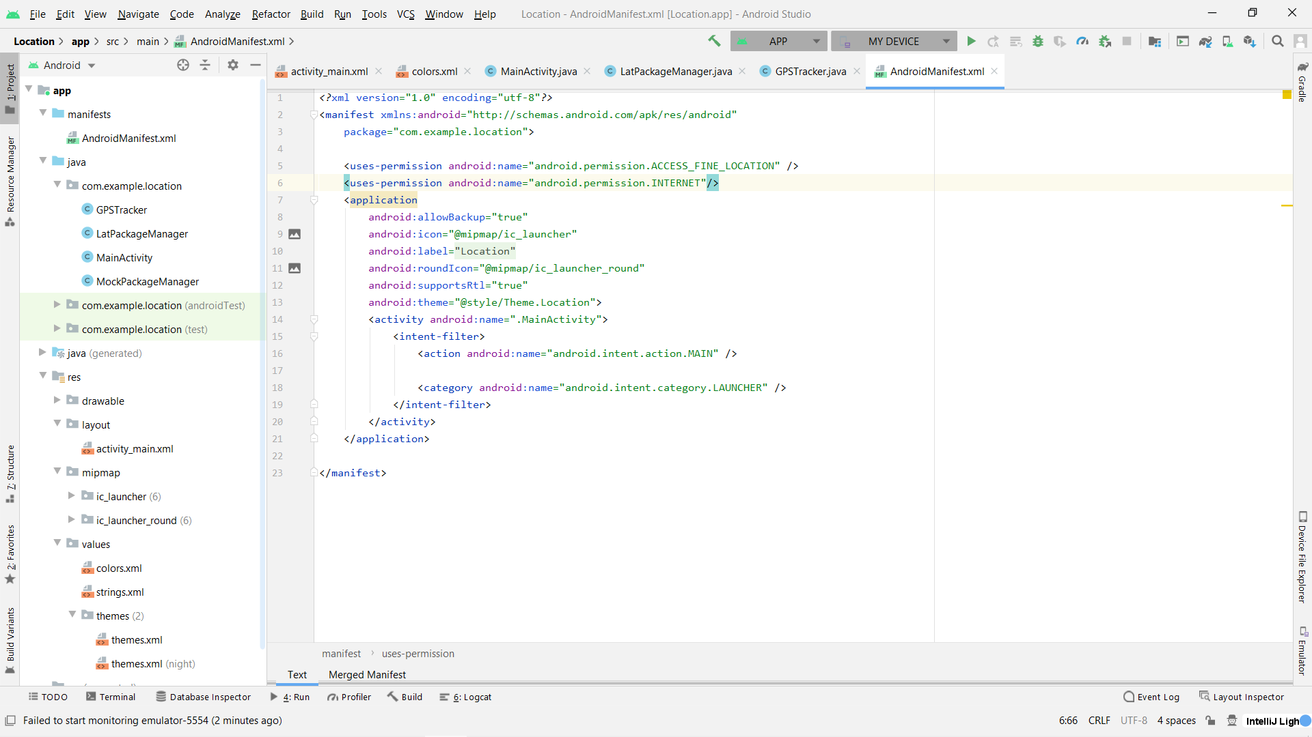

6.Manifest file.

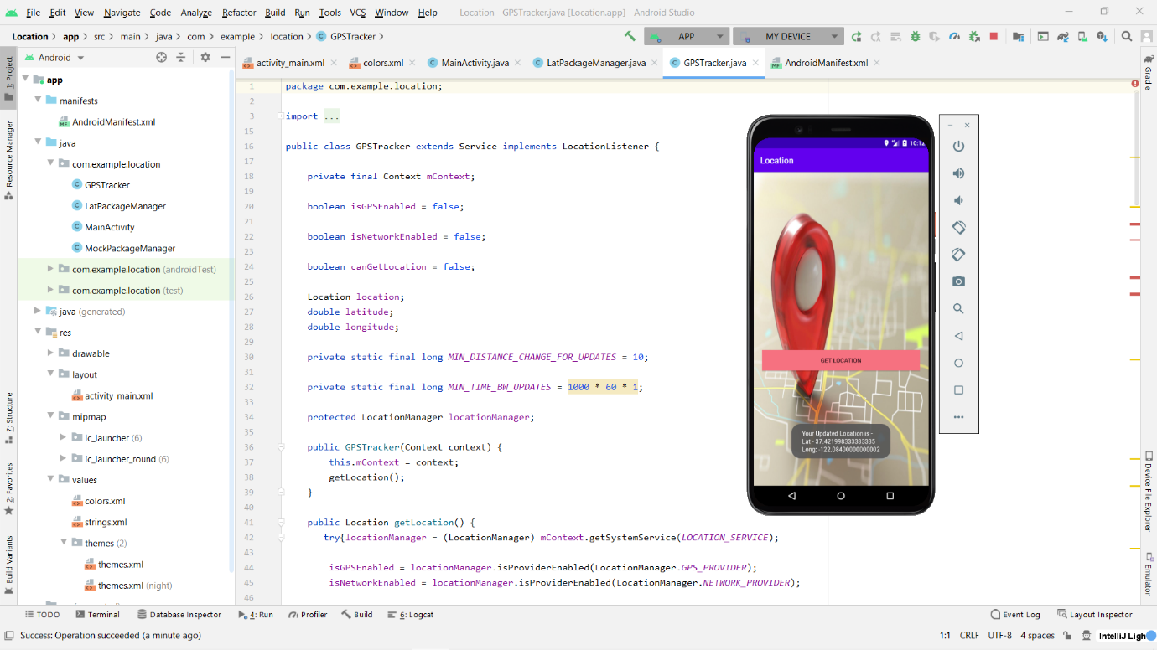

7.After Clicking the GET LOCATION button we get the longitude and latitude.

**CONCLUSION:-**

In this project I am able o understand the use of Android Studio Software. In it I use the main location framework of java which is already in Java inbuild. It is very helpful project to find the location of any person. But in it I use the longitude and latitude of the project. Longitude and latitude we get in degree for and time form.